# HuRRI | Hurricane Resilience Research Institute

## I. COVER PAGE

|  |  |  |  |
| --- | --- | --- | --- |
| **PI Name:** |  | PI Employee ID#: | |
| PI Department: |  | PI  University: |  |
| PI Email: |  | PI Phone: |  |
| **Co-­‐PI Name:** |  | Co-­‐PI Employee ID#: | |
| Co-­‐PI Department: |  | Co-­‐PI  University: |  |
| Co-­‐PI Email: |  | Co-­‐PI Phone: |  |
| **Other Investigators (Include their Dept/University/Email and Phone)** |  | | |
| **Project Title:** |  | | |
| **Total Funds Requested:** |  | | |

Select Research Area (check all that apply):

Mitigation  Assessment  Prediction  Protection  Education  Recovery

Crosscutting (specify general area or topic):

Does this proposal involve (check all that apply)?

Animals  Research Involving Recombinant DNA Molecules

Human Subjects  Radioisotopes

If so, indicate approval status:

Application submitted

Application submitted and approved on

Application has not yet been submitted

SIGNATURE:

Principal Investigator Date

**Wireless Carbon Nanofiber Aggregate Sensor System for Real-Time Water Level Monitoring and Flood Warning**

**Abstract.** Texas consistently leads the nation in flood deaths[1] and the majority of those deaths are in vehicles[2]. Many accidents, rescues, and deaths occur at low water crossings, and most occur at night. The objective of this research is to investigate low-cost means to better alert the driving public to the risks of low water crossings. Specifically, we will develop a Carbon NanoFiber Aggregate (CNFA)-based water level sensing and flood warning system with the following objectives: 1) conduct a comprehesive evaluation of flood sensors and flood warning devices and management approaches of low water crossings; 2) develop low-cost CNFA sensors for accurate water level measurement; 3) develop a microcontroller-based display/alert system using wireless communication technologies, and 4) perform controlled environment tests and compare with results from conventional measurements. A rational design method and approperiate construction practices will be established for the CNFA-based water level monitoring and flood warning system. The proposed technology can be widely deployed in many urban, suburban, and rural communities and could greatly improve driver safety at low water crossings.

Introduction. According to the survey on the loss of lives due to flooding, it is seen that the state of Texas is at the top in flood-related deaths in the United States every year. In addition, about 50% of all flood casualties countrywide involve vehicles[3] which indicates the need of provision of effective systems for flood level indication. This HuRRI project proposes a reliable wireless carbon nanofiber aggregate (CNFA) sensor system[4-10] as shown in Fig. 1 that can be embedded at the lower regions of bridges or highway/roadway infrastructures for real time water level monitoring during heavy rains or floods. The wireless CNFA sensor[11] system can play a vital role in avoiding the risk of casualties caused by floods.

Objective. The team will rely on their expertise in civil infrastructure design, wireless sensing and communication system design to explore effective and low-cost flood monitoring solutions. Specifically, the following objectives will be accomplished: 1) develop novel low-cost and robust CNFA sensors for accurate water level measurements; 2) develop in-situ noise-resilent CNFA water level sensor interface circuits and wireless data communication system; 3) develop a microcontroller-based LED event notification and alert system, and 4) perfom comprehensive field tests to validate the functionality, performance and robustness of the overall system.

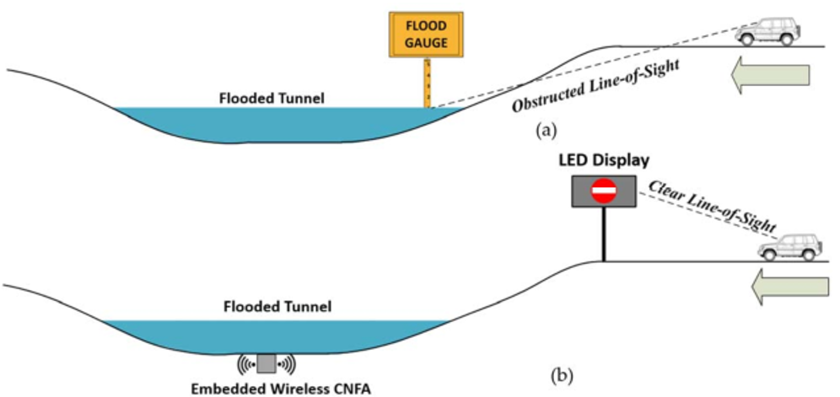

Fig. 1. (a) Traditional flood gauge with obstructed line-of-sight and (b) the proposed embedded wireless CNFA flood level monitoring with clear line-of-sight.

Approach: To achieve the objectives, the research team proposes four tasks as follows:

Task 1: Develop CNFA sensors for water level detection. The development of the CNFA sensors for water level detection includes the following subtasks: 1) investigation of the types of carbon nanofibers; 2) examination of the ingredients of carbon nanofiber aggregates; 3) evaluation of weight percentage of carbon nanofibers to cement[12-13]; 4) refinement of the formwork required for casting CNFA[9]; and 5) water chamber testing of CNFA water level sensors.

Task 2: Develop CNFA sensor interface electronics and its wireless communication system and a microcontroller-based flood warning module. This task is to advance the existing CNFA sensor with radio frequency (RF) connection for data transmission and microcontroller for data processing and event notification. Cost-effective and ultra-low power RF transceiver and microcontroller modules meeting the overall system requirements[14-15] will be identified. The wireless system and the microcontroller data processing unit will be designed and implemented on printed-circuit boards (PCBs). Further, solar energy power sources and power management circuits will be designed and tested and integrated into the entire system. This task will also develop a LED warning display module to inform motorists about the level of water accumulated at low water crossings. This warning display will be provided in such a way that public can notice the warning before entering the flood-prone area and change their route of travel. Different water levels will trigger local and/or remote warnings to notify motorists and/or agencies.

Task 3: Conduct developmental testing. This task will validate the functionality, performance, robustness and reliability of the system in the fields during heavy rains and high winds. Major field tests will include (1) reliable and robust operations of the CNFA sensor measurement unit[16-20], including high water testing, waterproof testing, immunity to corrosion, trash and debris and high winds- and heavy water-induced movement, measurement accuracy and systematic offset calibration; (2) usability of the radio transceiver, antenna gain, and antenna line-of-sight propagation to ensure the radio transceiver[14-15] has error-free coverage of the communication range; (3) reliable operation of the solar power system including the solar panel, the battery, the charge controllers, and the custom-built power management circuit; (4) long-term usage tests and power consumption tests; and (5) System integration test during complete heavy rain cycles.

Task 4: Preparation of Final Report. The research team will document all research findings from this project. The documentation/deliverables will be used as preliminary results in future proposals.

Time Frame. The proposed project will be performed over the course of 12 months. The project timeline is shown in Table 1.

Table. 1. Program plan for a duration of 12 months

|  |  |  |  |  |  |  |  |  |  |  |  |  |  |
| --- | --- | --- | --- | --- | --- | --- | --- | --- | --- | --- | --- | --- | --- |
| No. | Tasks | 9 | 10 | 11 | 12 | 1 | 2 | 3 | 4 | 5 | 6 | 7 | 8 |
| Task 1 | 1. Investigation of the types of carbon nanofibers |  |  |  |  |  |  |  |  |  |  |  |  |
| 2. Examination of the ingredients of carbon nanofiber aggregates |  |  |  |  |  |  |  |  |  |  |  |  |
| 3. Evaluation of weight percentage of carbon nanofibers to cement |  |  |  |  |  |  |  |  |  |  |  |  |
| 4. Refinement of the formwork required for casting CNFA |  |  |  |  |  |  |  |  |  |  |  |  |
| 5. Water chamber testing of CNFA water level sensors |  |  |  |  |  |  |  |  |  |  |  |  |
| Task 2 | CNFA sensor interface electronics and Access OBU wireless module |  |  |  |  |  |  |  |  |  |  |  |  |
| Task 3 | Conduct developmental testing |  |  |  |  |  |  |  |  |  |  |  |  |
| Task 4 | Preparation of Final Report |  |  |  |  |  |  |  |  |  |  |  |  |

**Equipment and Facilities**

The Advanced Materials Laboratory, the Structural Research Laboratory, the Integrated Circuits and Microsystems Laboratory and the Systems Research Laboratory at UH and TTU have necessary equipment and facilities to carry out nanomaterial testing, civil infrastructure development and testing, sensor design and fabrication, and embedded system design and wireless communication system design and testing.

**Internal and External Funding**

PIs have no active internal funding. Regarding external funding, the concept of CNFA sensor was partly developed by an NSF grant titled “REU Site: Undergraduate Research Experience in Civil Infrastructure Engineering”. The PIs are currently working on several ongoing projects funded by NSF, TxDOT and private industry companies.

**Future Proposal Submissions**. With the preliminary results to be obtained from this project, PIs plan to submit consortium and collaborative proposals to funding agencies as follows:

|  |  |  |  |  |
| --- | --- | --- | --- | --- |
| Funding Agency | Proposal Type | Proposal Title | Duration | Budget |
| Tx GLO | State | Carbon Nanofiber Aggregate Sensors for Low Water Crossing in Texas | 9/1/2018 – 8/31/2021 | $2 million |
| U.S. DOE | Federal  consortium | Carbon Nanofiber Aggregate Sensors for Sustaining Resilience of Nuclear Infrastructures to Multi-Hazards | 10/1/2019 – 9/30/2022 | $2.4 million |
| U.S. DOT | Federal  collaborative | University Transportation Center-Resilience Enhancement of Coastal Transportation Infrastructure under Multi-hazard Effects | 10/1/2019 – 9/30/2024 | $2.75 Million |

The PIs intend to form an “NSF Engineering Research Center for Sustainable Multi-Hazards Resilient Civil Infrastructures”, which will bring transformational research in civil infrastructure engineering at the crossroad of civil engineering, electrical and computer engineering, material engineering, and mechanical engineering. This project will lay ground work in this direction by developing an innovative low cost wireless carbon nanofiber sensor that has the same lifespan as the civil infrastructure.

Reference

1. Bedient, Philip, and Jim Blackburn. Lessons from Hurricane Ike. Texas A&M University Press, 2012.
2. Chris Dolce. At least 234 people have been killed by flooding in the U.S. in nearly 18 months. The Weather Channel, June 26, 2016. https://weather.com/storms/severe/news/flood-deaths-united-states-near-200.
3. National Weather Service. Floods, https://www.weather.gov/media/bis/Floods.pdf, March 2005.
4. Howser, R. N, “Development of multifunctional carbon nanofiber aggregate for concrete structural health monitoring,” Doctoral dissertation, University of Houston, 2013.
5. Kline C.R., “Surface-etched etched alumina/SiC mini-whisker composite material and uses thereof,” US Patent Number, 8426328 B2, April 23, 2013.
6. Bontea, D.-M., Chung, D. D. L., and Lee, G. C., “Damage in carbon fiber reinforced concrete, monitored by electrical resistance measurement,” Cement and Concrete Research, 30(4), 651–659, 2000.
7. Chen, P.-W., and Chung, D. D. L., “Concrete as a new strain/stress sensor,” Composites Part B: Engineering, 27(1), 11–23, 1996.
8. Chung, D. D. L., “Strain sensors based on the electrical resistance change accompanying the reversible pull-out of conducting short fibers in a less conducting matrix,” Smart Materials and Structures, 4, 59–61, 1995.
9. Gao, D., Sturm, M., and Mo, Y. L., “Electrical resistance of carbon-nanofiber concrete,” Smart Materials and Structures, 18(9), 2009.
10. Li, H., Xiao, H., Yuan, J., and Ou, J., “Microstructure of cement mortar with nano-particles,” Composites Part B: Engineering, 35(2), 185–189, 2004.
11. Mo, Y. L., Howser, R., Dhonde, H., and Song, G., "Systems and methods utilizing carbon nanofiber aggregate for performance monitoring of concrete structures," US Patent Number: 9797937, October 24, 2017.
12. Liao, W. C., Chao, S. H., Park, S. Y., & Naaman, A. E., “Self-consolidating high performance fiber reinforced concrete (SCHPFRC)–preliminary investigation.” Report No. UMCEE 06, 2, 2006.
13. ACI Committee 318. (2014). Building code requirements for structural concrete (ACI 318-14) and commentary. American Concrete Institute. Farmington Hills, MI, USA.
14. J. D. Beshay, J. Chen, et al, “Wireless networking testbed and emulator (WiNeTestEr)”, Computer Comminications, vol. 73, Part A, pp. 99-107, January 2016.
15. Y. You, J. Chen, et al "A 12GHz Low-Jitter LC-VCO PLL in 130nm CMOS," Journal of Instrumentation, vol. 10, no. 3, Journal of Instrumentation, JINST 10(03):C03013, March 2015.
16. L Xiao, J. Chen, et al, ,"LOCx2, A low-latency, low-overhead 2x5.12 Gbps transmitter ASIC for the ATLAS liquid argon calorimeter trigger upgrade," Journal of Instrumentation, vol. 11, no. 2, JINST 11(02):C02013, , February 2016.
17. L. Xiao, J. Chen, et al, "The clock and control system for the ATLAS liquid argon calorimeter Phase-I upgrade," Journal of Instrumentation, vol. 11, no. 1, JINST 11(01):C01062, January 2016.
18. L. Xiao, J. Chen, et al, "A low-power low-latency dual-channel serializer ASIC for detector front-end readout," Journal of Instrumentation, JINST 12 C01049, 2017.
19. Y. Feng, J. Chen, et al, "A low-power 12.5Gbps serial link transmitter ASIC for particle detectors in 65nm CMOS," Journal of Instrumentation, JINST 12 C02063, 2017.
20. Y. Tang, J. Chen et al, "Wideband LNA with 1.9dB noise figure in 180nm CMOS for high-resolution ultrasound imaging applications," IEEE NEWCAS'2016, Vancouver, Canada, June 26-29, 2016.